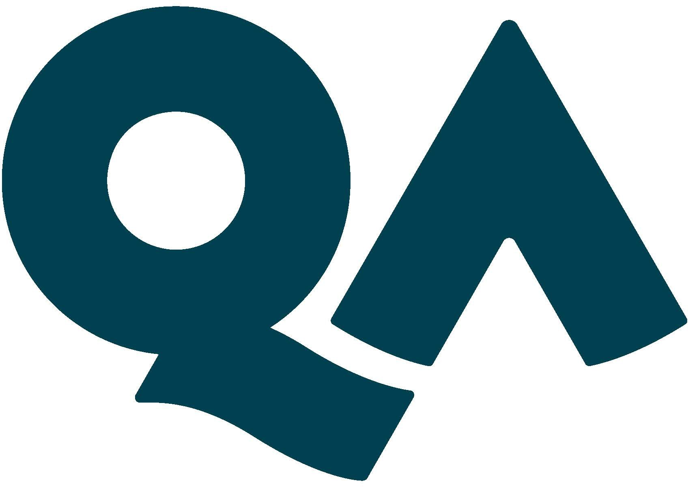

JOB
DESCRIPTION

- Job specifics
Job Title: | DS5 – Senior Client Relationship Manager
Reports to:
Location:
Department: | Sales

- About the role
What you’ll be doing? | You will lead engagement’s with establish Customers to grow revenue streams against targets. As a Senior Account Manager, you will also be required to perform the role to the highest standard, acting as a positive role model within your team.
Key Responsibilities | Manage relationships with existing key stakeholders to grow the QA share of wallet.  Prospect existing customers for new stakeholders to grow our product footprint and increase revenue streams.  Lead client meetings to understand their business in order to deliver impactful solutions.  Drive broader commercial discussions, prepare quotes and proposals to deliver high quality written material for client sign off.  Utilise market data and analyse/interpret all relevant sales management information to strategically prioritise your sales pipeline and time in order to maximise financial performance.  Utilise the CRM to capture data and build client knowledge.  Build and own robust and progressive account plans for each customer with a view to increasing diversity in engagement and revenue streams.  Deliver high levels of customer service that build on existing long-term commercial relationships. Review customer satisfaction via service reviews and action positive change.  Develop an in-depth understanding/knowledge of your product offering to ensure accurate positioning within the defined market space  Design high-level creative solutions to meet customer needs. This may involve leading a small bid team with Subject Matter Experts to create a compelling solution.
KPIs & SLAs | Generate revenue and profitability in line with individual target.  Maintain and grow existing customer base.  Grow overall contact/coverage of client through a number of touch points.
Key Working Relationships | Sales, Finance and Delivery teams, Practice Directors, Bids, Operations.

- About You
Your Competencies  1: Working Level  2: Advanced Level  3: Expert Level | Core  Results Driven – 2  Taking Ownership – 2  Collaboration – 2  Continuous Learning – 2  Role Specific  Customer Focus – 2  Influence & Persuasion – 2  Stakeholder Management – 2  Mentoring & Coaching – 1
Your Experience | Track record of achieving sales targets through a wide range of products  B2B sales experience  Experience of selling services and solutions  Proficient in using IT systems e.g. Client Relationships Management systems
Your Knowledge | Understanding of consultative sales techniques  Strong knowledge of the sales cycle from initial contact/prospecting to purchasing service offerings  Full understanding of how to deliver great customer service  Understanding of how to effectively coach and mentor team members
What you’ll bring to QA | Customer centric with an entrepreneurial attitude  Strong personal values that align with QA’s  Willingness to undertake DBS, BPSS, SC, DV, Disclosure Scotland or similar if required for the role
Diversity & Inclusion | QA are able to make reasonable adjustments based on part-time work, child-care or developmental disorders that may need to be taken into consideration.

